Overload Alert By Automatic Elevator

Name of Authors: 1. Bhushan R.Gadekar, 2. Garvita P. More, 3.Chaitali S. Nehe

Name of Guide: Prof. M.R.Gunjal.

Name of Institute: Sanjivani K.B.P.Poytechnic, Kopargaon, Nagar.

# ABSTRACT

As we know that there is several problems happens in conventional elevators like man trapping, car become inoperative when it is overloaded, lift maintenance mode etc.. The main theme behind the project is that, the preventive measures must be took lift by itself. The proposed work comprises of a sensor module which has the capability to monitor and control through internet service. Whereas, the conventional lift system provides only limited information such as floor number under similar operating conditions, our proposed monitoring system can display the number of person who enter into Elevator & also measure their weight and help itself in fault condition and rescue people in that condition .

**Keywords**: Automated ,Elevator, Passengers , Overload, Alert , ARDUINO .

# INTRODUCTION

Elevator, also called lift, car that moves in a vertical shaft to carry passengers or freight between the levels of a multistory building. Most modern elevators are propelled by electric motors, with the aid of a counterweight, through a system of cables and sheaves (pulleys). The working principle of an elevator or lift is similar to the pulley system. A pulley system is used to draw the water from the well. This pulley system can be designed with a bucket, a rope with a wheel....

When the switch is turned ON, the motor can be activated when the elevator goes up and down or stops. The main aim of this Automated Elevator With Overload Alert is to prevent the elevator from any damage. This system makes use of sensors for sensing when a person enters the elevator and automatically increments the counter. this buzzer starts ringing as soon as the number of people in the elevator exceeds the limit .

This system helps to indicate limit of an elevator, which is how many people can be inside an elevator at a particular time. The system displays the number of people inside an elevator with the help of 7 segment display. Each pair consists of 2 sensor pairs placed at a certain distance from one another in the opposite direction. The system includes Infrared Sensor pairs which are placed near the elevator door. These sensors senses when a person enters an elevator and it opens the door of the elevator and simultaneously increments the counter for the number of people entering the elevator. In simple terms, an elevator can be defined as a kind of transportation that moves in the vertical direction whilst carrying people and baggage between the floors (or levels) of a building or any other type of structure.

Elevators, or lifts, exist in several different forms but their method of operation is common; to lift materials in a tall tower or construction site in a continuous flow. Electric motors are used in general to power elevators by driving hoist like systems . Whether they are used in agricultural fields or in the manufacturing industries, elevators serve the basic purpose of reducing manual effort to carry heavy loads from one place to another in any infrastructure. Elevators are a Godsend discovery for handicapped and disabled people who cant be expected to use stairs (or escalators in case of wheelchairs) to ascend or descend in a multi-storied building. Moreover, in most high-rise buildings it is often a legal requirement to have elevators as wheelchair ramps wouldn’t be practical there.

# PROBLEM STATEMENT / OBJECTIVE

* To avoid the inconvenience caused by elevator breakdowns, this project is gaining widespread attention.
* The system can be made far better and protected against factors such as vandalism and overload if an operator were to be present in the elevator at all times.
* The main target of the automated elevators control system is to bring the lift car to the right floor when needed. to ensure a speed that is within the limits of safety and minimalizes the time travel and also provides comfort to the passengers.
* Final year electrical engineers have modernized the system by using a 7-segment display to disclose the number of people present inside of the elevator.
* Infra- Red sensor pairs are placed near the lifts door that sense a person entering or leaving the lift.
* When the Infra-Red sensors sense an incoming person, they open the elevator doors and at the same time cause an increment in the counter for the number of people arriving.

# PROPOSED METHODOLOGY

The main theme behind the project is that, the preventive measures must be took lift by itself. The preventive measures will be controlled and monitored by Arduino UNO in co-ordination of few sensors and output devices, the theme is that a weight and counting parameters will be calculated during the operation of elevator car by the pressure and IR sensors, ventilation duct will be get operated automatically when man trapping scenarios etc.

As per above mentioned cases the public information display(16x2) system, indication lamp and buzzers will be operated accordingly .

Operation and execution of the project as follows, when passengers enter and exit from the elevator car then increment and decrement will be counted by IR sensor and that counted parameters sent to the Arduino UNO for the further process like information on display, stopping algorithm. Meanwhile that car analyze the weight with the help. of load sensor and sends measured signals to Arduino UNO for next actions and buzzer alarm, indication will operate accordingly.

As per the programed Arduino UNO decides whether that car shall operational or not. In case of stopping of elevator car at any level that means passengers can stuck any level, so for bringing the passenger at nearest level it requires some time and due to which suffocation can be happened that's why ventilation duct will be open with the help of motors when this scenario happens.

.

# 5. BLOCK DIAGRAM

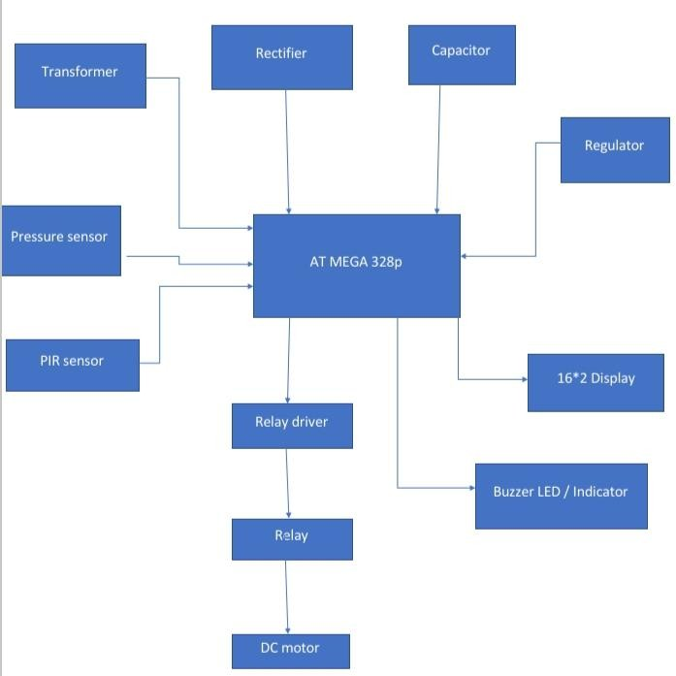

**5.CONCLUSION**

Present scope of the project is to provide an automatic congestion control. And hence found its importance in various fields of applications .It can be extended for multi-stories as well.This system help itself in fault condition and major accidents will be avoided due to failure of Elevator. This system will definitely benefic for elders.

# REFERENCE & BIBLIOGRAPHY

1. Prof. Omkar M.Shete ,Divyani V. Shete , Saurabhi G.Pise “SURVEY PAPER ON DESIGN & CONTROLOF AN ELEVATOR FOR SMART CITY APPLICATION” Vol-6, Issue-4, April 2017
2. Prof Marije Andrija Balug, Spoljaric Goran Vujisic “Laboratory Model Of the elevator Controlled by ARDUINO Platform” MIPRO 2017, May 22-26, 2017, Opatija Croatia
3. Rushikesh Rajendra Khadilkar, Jayesh Totaram Bharambe, Ajinkya Goroba Keskar , Eshwat Rajendra Dhande “ A research paper on control of an elevator in case of failure of rope holding the inside cage”

V. Udayashankara and M. S. Mallikarjunaswamy: 8051